 

INSTITUTE FOR ADVANCED COMPUTING AND SOFTWARE DEVELOPMENT AKURDI, PUNE

Documentation On

**“WEB BASED RECRUITMENT SYSTEM”**

PG-DAC FEB 2020

*Submitted By:*

**Group No: 71 Names & roll numbers**

**Shubham Rode 1204**

**Tanmay Pagare 1169**

**Prashant Karhale Mr.Milind Arjun**

**Centre Coordinator Project Guide**

# Table of Contents

1. Introduction 4

Document Purpose 4

Problem Statement 5

Product Scope 5

Aim & Objectives 5

1. Overall Description 6

Product Perspective 6

Benefits of Web based recruitment system 7

User and Characteristics 7

Operating Environment 8

Design and Implementation Constraints 9

1. Requirements Specification 9

External Interface Requirements 9

3.3 Non-Functional Requirements 10

1. System Diagram 11

Activity Diagram 11

Data Flow Diagram 12

Use Case Diagram 13

ER Diagram 14

1. Table Structure 15

Candidate Register 15

Candidate work experience 16

Recruiter Register 16

Recruiter job post 17

Applied job post 17

Admin 18

1. Conclusion 18

Future Scope 18

1. References 18

**List of Figures**

Figure 1 Activity Diagram 11

Figure 2 DFD Diagram 12

Figure 3 Use Case Diagram 13

Figure 4 ER Diagram 14

# Introduction

The Web Based Recruitment System is a web based Application intended to provide complete solution for the Recruiter as well as for Job seeker through a single get way using an internet. It will enable the Job recruiters to post various job related openings in there company, and job seeker can browse and search job and apply according to him/her education, location and skills through internet. By doing so Particular Recruiter can get all the information related to job Seeker and can contact him/her through email and contact number. The Admin module will have all the right to rectify fake and unrelated information uploaded in the web and manage various job related post.

## Document Purpose

Due enhancement in Technology and internet, Web Application has greatly enhanced various business processes and communication between Job Seeker and the company Recruiter who want the suitable candidate for their job. This Web Based Recruitment System is developed to provide the following services:

JOB SEEKER:

* Job Seeker can add his or her Personal, Educational details and can update his or her profile on go.
* Job Seeker can add his or her work experience as many as he or she want and can update it.
* Job Seeker can Search for a job according to job title and location and can apply that particular job.

Recruiter:

* Recruiter can add and update his or her personal as well as company details.
* Recruiter can Post job vacancy and he or she can update that job vacancy.
* Recruiter can view Candidate information who had applied for that particular job.

Admin:

* Admin can view, update, delete Candidate details.
* Admin can View, update, delete Recruiter details
* Admin can View, update, delete Vacancy.
* Admin can view, update, delete applied candidate.

## Problem Statement

Early Recruitment system was based on a very traditional way by posting job vacancy in the newspaper or advertises the vacancy by pamphlet. Here candidate have to surf up through all the advertisement to search for his or her vacancy as per skills. It was difficult to segregate the requirement the job in this huge advertisement which consists of 100 ads in it. By Recruiter point of view he or she have to put and ad which required lot of money for just one newspaper, the cost of ads may increase as per newspaper. So by our propose software we can overcome this particular problem and make both job seeker and recruiter job easier1

## 

## Product Scope

This project covers through all types of job, by various type of industries and their requirement as per the company objective and for job seeker he or she can view job post according to location profile and skills. Following are the core objective that can be used

* Industry type: Industry can be various type it can be IT, manufacturing, support, networking and much more all this type is supported by our software
* Asp.NET Technology used for the development of the application.
* Fresher as well as experience candidate can apply to the job.
* Job seeker as well as recruiter personal information is safe because of role wise login system.

## Aims & Objectives

Specific goals are: -

* To produce a web-based system that allows the job seeker to add and update his or her details and can view job as per designation and location.
* Recruiter can add and update his or her details and can post vacancy.
* Recruiter can view all the details of candidate who had applied for the his or her job post.

# Overall Description

## Product Perspective:

Existing system function:

Early Recruitment system was based on a very traditional way by posting job vacancy in the newspaper or advertises the vacancy by pamphlet. Here candidate have to surf up through all the advertisement to search for his or her vacancy as per skills. It was difficult to segregate the requirement the job in this huge advertisement which consists of 100 ads in it. By Recruiter point of view he or she have to put and ad which required lot of money for just one newspaper, the cost of ads may increase as per newspaper. This web based Application intended to provide complete solution for the Recruiter as well as for Job seeker through a single get way using an internet. It will enable the Job recruiters to post various job related openings in there company, and job seeker can browse and search job and apply according to him/her education, location and skills through internet. By doing so Particular Recruiter can get all the information related to job Seeker and can contact him/her through email and contact number. The Admin module will have all the right to rectify fake and unrelated information uploaded in the web and manage various job related post.

* **III. PROPOSED SYSTEM**

*Create your own Resume:*

Candidate can create his own resume by registering to the website.

*Add one or more work experience:*

Candidate can be fresher or can be experience through more than one company so he or she can add more than one experience and can update it anytime.

*Enter Company details:*

Recruiter can create his or her company profile by registering to the website

*Post as many job vacancy as you can:*

Recruiter can have one or many vacancy in his or her company with respective to various designation and number of vacancy. So he or she can post vacancy number of times.

*View candidate Resume who had applied for the job:*

Recruiter can candidate Resume when he or she had applied to the particular Recruiter job post.

## Benefits of Web based Recruitment system

* This Web based Recruitment system is fully functional and flexible.
* It is very easy to use.
* This Web based Recruitment system helps candidate to find his or her dream job and for recruiter a candidate who can work on projects.
* It saves a lot of time for both job seeker and recruiter to do their job.
* Eco-friendly: The monitoring of the society management and the overall business becomes easy and includes the least of paper work.
* The application acts as an advertisement for the vacancy 24/7.
* It increases the efficiency of job offering as per designation and location.

## Users and Characteristics:

Admin:

* Admin can login to the system.
* View the list of all Candidates.
* Delete Candidate.
* Update Candidate.
* View the list of all Recruiter.
* Delete Recruiter.
* Update Recruiter.
* View the list of all job vacancy.
* Delete vacancy.
* Update vacancy r.
* View the list of all candidates who had applied to that particular job.

Job seeker:

* + Flat Owner can Register and login to the system.
  + View his/her details.
  + Update his or her details.
  + Add his or her work experience.
  + Search job as per job title and location.
  + Apply for particular job.
  + Delete or update his or her work experience.

Recruiter:

* + Recruiter can register and login to the system.
  + View his/her details.
  + Update his or her details.
  + Can add job vacancy.
  + View his all job vacancy.
  + Update and delete his job vacancy.
  + View who candidate details who had applied to his job post.

## Operating Environment:

Server Side (minimum requirement):

**Processor:** Intel® Xeon® processor 3500 series

**HDD:** Minimum 120GB Disk Space

**RAM:** Minimum 4GB **OS:** Windows 7, Linux 6 **Database:** Mysql

Client Side (minimum requirement):

**Processor:** Intel Dual Core

**HDD:** Minimum 80GB Disk Space

**RAM:** Minimum 1GB

**OS:** Windows 7, Linux

## Design and Implementation Constraints:

* The application will use HTML5, JavaScript, bootstrap and css as main web technologies.
* HTTP protocol are used as communication protocol.
* Several types of validations make this web application a secured one and SQL Injections can also be prevented.
* Since Web based recruitment system is a web-based application, internet connection must be established.
* The candidate and recruiter can use this web application on PC or in mobile due to bootstrap used in programming and will function via internet or intranet in any web browser.

# Specific Requirement

## External Interface Requirements:

User Interfaces:

* + All the users will see the same page when they enter in this website. This page asks the user is a candidate or recruiter.
  + After being Register he or she can login by role wise login system by correct input of username and password.
  + User will be redirect to their corresponding profile where they can do various activities.
  + The user interface will be simple and consistence, using terminology commonly understood by intended users of the system. The system will have simple interface, consistence with standard interface, to eliminate need for user training of infrequent users.

Hardware Interfaces:

* + No extra hardware interfaces are needed.
  + The system will use the standard hardware and data communication resources.
  + This includes, but not limited to, general network connection at the server/hosting site, network server and network management tools.

Application Interfaces:

**OS:** Windows 7, Linux

**Web Browser:**

The system is a web-based application; clients need a modern web browser such as Mozilla Firebox, Internet Explorer, Opera, and Chrome. The computer must have an Internet connection in order to be able to access the system.

Communications Interfaces:

* + This system uses communication resources which includes but not limited to, HTTP protocol for communication with the web browser and web server and TCP/IP network protocol with HTTP protocol.
  + This application will communicate with the database that holds all the booking information. Users can contact with server side through HTTP protocol by means of a function that is called HTTP Service. This function allows the application to use the data retrieved by server to fulfill the request fired by the user.

# System Design

## Activity Diagram

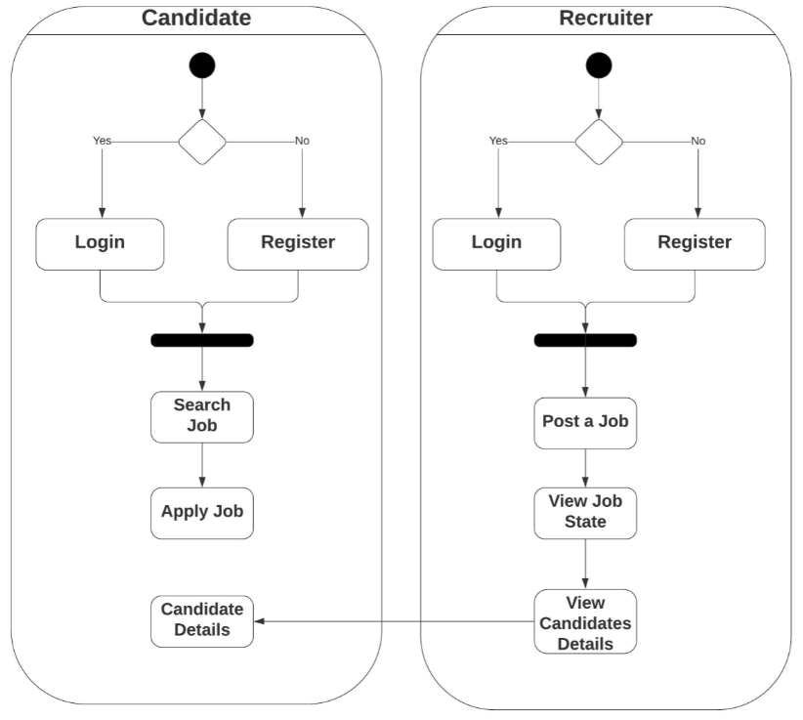

**Figure 1: Activity Diagram**

## Data Flow Diagram

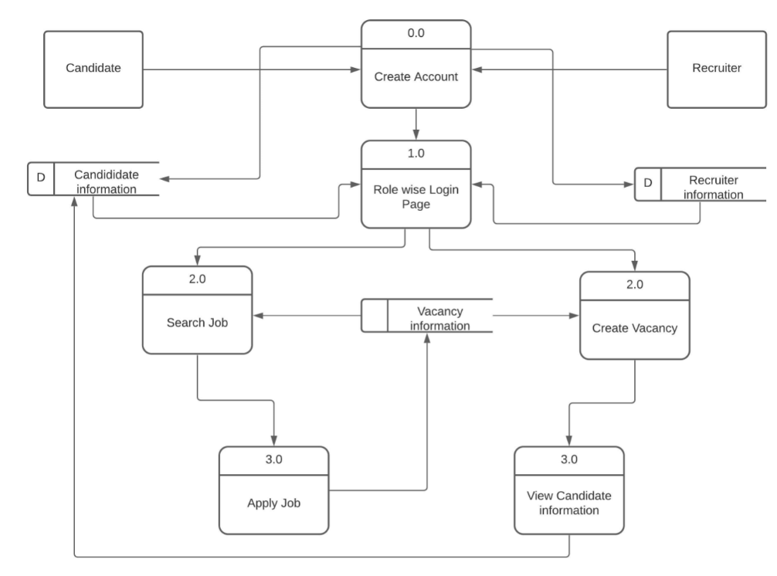

**Figure 2: Data Flow Diagram**

## Use Case Diagram

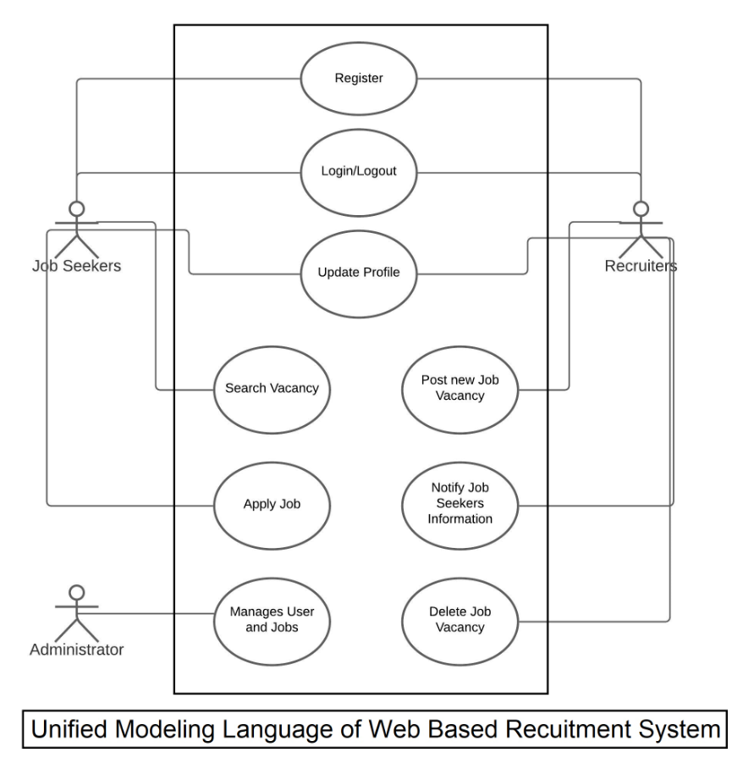

**Figure 3: Use Case Diagram**

## 

## ER Diagram

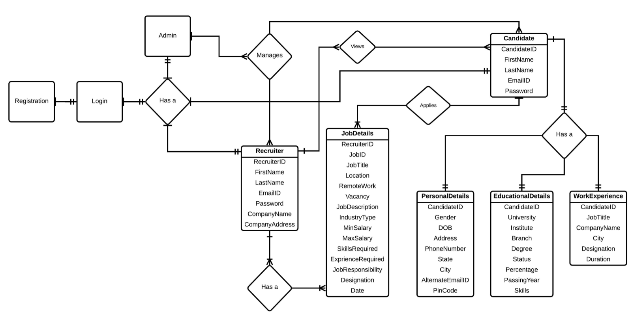

**Figure 4: ER Diagram**

# Table Structure

**Candidate** **RegisterTable:**

|  |  |  |  |
| --- | --- | --- | --- |
| **Candidate** **RegisterTable** | | | |
| **Field** | **Data Type** | **Size** | **Constraints** |
| CandidateID | int | 100 | Primary Key Auto Increment |
| FirstName | varchar | 50 |  |
| LastName | varchar | 50 |  |
| Email | varchar | 50 | Unique Key |
| Password | varchar | 50 |  |
| Gender | varchar | 10 |  |
| DOB | Date |  |  |
| Addr | varchar | 100 |  |
| PhoneNumber | varchar | 11 | Unique Key |
| State | varchar | 25 |  |
| city | varchar | 25 |  |
| Alternate EmailID | varchar | 50 | Unique Key |
| Pincode | number | 7 |  |
| Schoolname | varchar | 30 |  |
| tenthBoardname | varchar | 30 |  |
| schoolpercentage | double | 10,2 |  |
| schoolpassingyear | number | 5 |  |
| HSCcollegename | varchar | 30 |  |
| HSCboardname | varchar | 30 |  |
| HSCpercentage | double | 10,2 |  |
| HSCpassingyear | number | 5 |  |
| Collegename | varchar | 30 |  |
| Universityname | varchar | 30 |  |
| Stream | varchar | 30 |  |
| graduationpercentage | double | 10,2 |  |
| graduationpassingyear | number | 5 |  |
| projecttitle | varchar | 30 |  |
| projectDetails | varchar | 255 |  |
| Certification | varchar | 50 |  |

**Candidate Work Experience Details:**

|  |  |  |  |
| --- | --- | --- | --- |
|  |  |  |  |
| **Candidate Work Experience Details** | | | |
| **Field** | **Data Type** | **Size** | **Constraints** |
| ExpId | Int | 100 | Primary Key |
| CandidateID | Int | 100 | Foreign Key |
| Job Title | varchar | 25 |  |
| Company name | varchar | 50 |  |
| City | varchar | 15 |  |
| Designation | varchar | 15 |  |
| Duration | int | 3 |  |

**Recruiter Register Table:**

|  |  |  |  |
| --- | --- | --- | --- |
| **Recruiter Register Table** | | | |
| **Field** | **Data Type** | **Size** | **Constraints** |
| RecruiterID | Int | 100 | Primary Key Auto Increment |
| FirstName | varchar | 50 |  |
| LastName | varchar | 50 |  |
| Email | varchar | 50 | Unique Key |
| Password | varchar | 50 |  |
| CompanyName | varchar | 50 |  |
| CompanyAddress | varchar | 50 |  |

**Recruiter Job Details Table:**

|  |  |  |  |
| --- | --- | --- | --- |
| **Recruiter Job Details Table** | | | |
| **Field** | **Data Type** | **Size** | **Constraints** |
| RecruiterID | Int | 100 | Foreign key |
| JobId | int | 1000 | Primary Key Auto Increment |
| JobTitle | varchar | 50 |  |
| Location | varchar | 25 |  |
| Remote Work | varchar | 4 |  |
| Number of Vacancy | number | 2 |  |
| Company Description | varchar | 255 |  |
| Industry Type | varchar | 25 |  |
| Company Size | number | 10 |  |
| Employment type | varchar | 25 |  |
| Min salary | Int | 5 |  |
| max salary | int | 9 |  |
| Skills required | varchar | 255 |  |
| Experience required | int | 3 |  |
| Job Responsibility | varchar | 255 |  |
| Designation | varchar | 25 |  |
| Date Posted | date |  |  |

**Applied Job Details Table:**

|  |  |  |  |
| --- | --- | --- | --- |
| **Applied Job Details Table** | | | |
| **Field** | **Data Type** | **Size** | **Constraints** |
| appliedId | int | 100 | Primary Key Auto Increment |
| CandidateID | int | 100 | Foreign key |
| JobId | int | 100 | Foreign key |
| status | Boolean | 1 |  |

**Admin:**

|  |  |  |  |
| --- | --- | --- | --- |
| **Field** | **Data Type** | **Size** | **Constraints** |
| AdminID | Int | 100 | Primary Key |
| FirstName | varchar | 50 |  |
| LastName | varchar | 50 |  |
| Email | varchar | 50 | Unique Key |
| Password | varchar | 50 |  |

**Conclusion**

Web Based Recruitment system manages Candidates resume as well as Recruiter Job Post and all Personal details. Candidate can make a Resume and Search job by title and City. Candidate can add one or more work experience. Recruiter can add one or more vacancy and can view Resume of the Candidate who had applied to his job. Both Candidate and Recruiter can manage all the functionality anywhere and anytime on go.

# Future Scope

This project can be enhanced further by adding following features:-

* Candidate can download his/her Resume.
* Recruiter can make interview call to the applied candidate.
* Recruiter can send a private message to applied candidate.
* Additional Payment method for premium candidates.
* Candidate can view Recruiter Company Review and also give your own reviews.

# References

1. Computer Systems and Applications (AICCSA), 2010 IEEE/ACS International Conference
2. “Web-based recruiting Frameworks for CV structuring” structuring Soumaya Amdouni Institut Supérieur de Gestion Cité Bouchoucha, Le Bardo, TUNISIA.

**ONLINE REFERENCE**

1. <https://hrsystems.admin.cam.ac.uk/hr-admin-ui/>
2. https://www.lovelycoding.org/recruitment-management-system/